**B_18_DAYAL ADITYA KISHOR**

**ASSIGNMENT-4**

**create table Sailor(sid int primary key,sname varchar(20),rating int,age real);**

**desc Sailor;**

**create table Boat(bid int primary key,bname varchar(20), color varchar(20));**

**create table reserves(sid int,bid int,day date,foreign key(sid) references Sailor(sid) on delete cascade,foreign key(bid) references Boat(bid) on delete cascade);**

**desc reserves;**

**insert into Sailor values(22,'Dustin',7,45.0);**

**insert into Sailor values ( 29, 'Brutus', 1, 33.0 );**

**insert into Sailor values ( 31, 'Lubber', 8, 55.5 );**

**insert into Sailor values ( 32, 'Andy', 8,25.5 );**

**insert into Sailor values ( 58, 'Rusty', 10, 35.0 );**

**insert into Sailor values ( 64, 'Horatio', 7, 35.0 );**

**insert into Sailor values ( 71, 'Zorba', 10, 16.0 );**

**insert into Sailor values ( 74, 'Horatio', 9, 35.0 );**

**insert into Sailor values ( 85, 'Art', 3, 25.5 );**

**Select * from Sailor;**

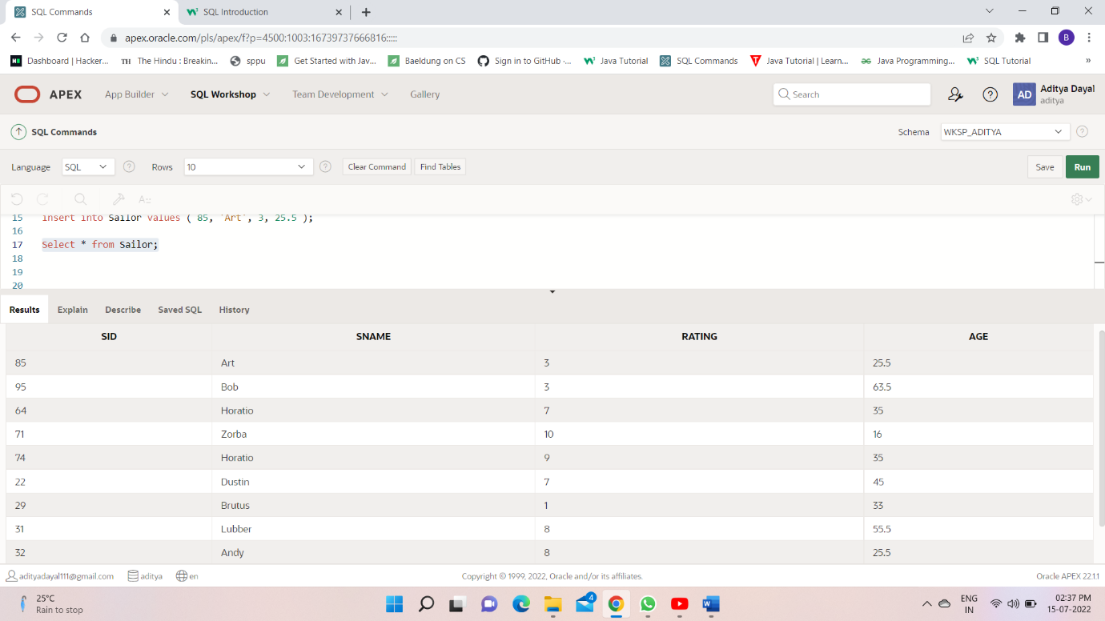

insert into Boat values(101,'Interlake', 'blue');

insert into Boat values(102,'Interlake', 'red');

insert into Boat values(103,'Clipper', 'green');

insert into Boat values(104,'Marine', 'red');

Select *from Boat;

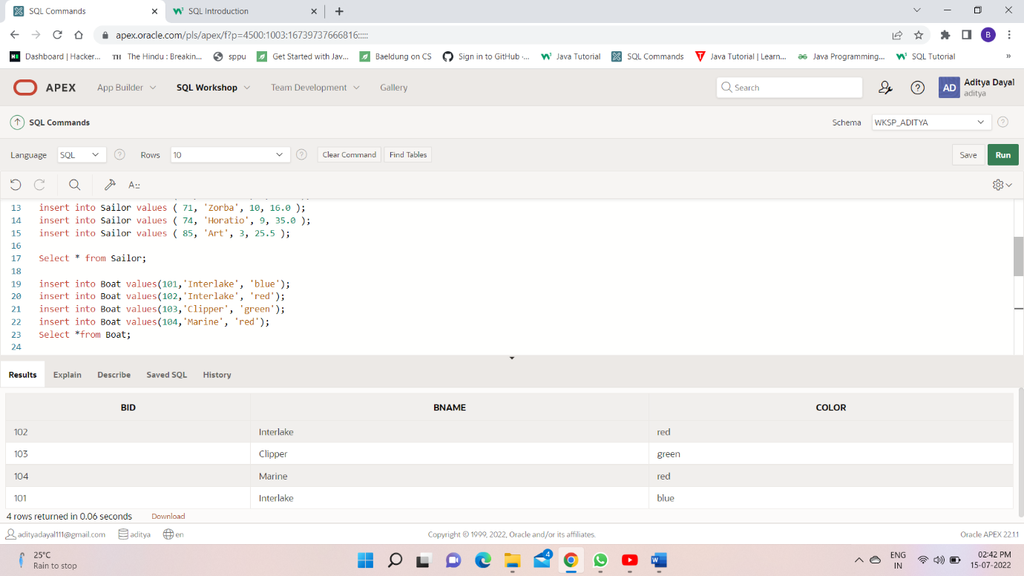

insert into Reserves values(22,101,'10/10/1998');

insert into Reserves values(22,102,'10/10/1998');

insert into Reserves values(22,103,'10/8/1998');

insert into Reserves values(22,104,'10/7/1998');

insert into Reserves values(31,102,'11/10/1998');

insert into Reserves values(31,103,'11/6/1998');

insert into Reserves values(31,104,'12/12/1998');

insert into Reserves values(64,101,'9/5/1998');

insert into Reserves values(64,102,'9/8/1998');

insert into Reserves values(74,103,'9/8/1998');

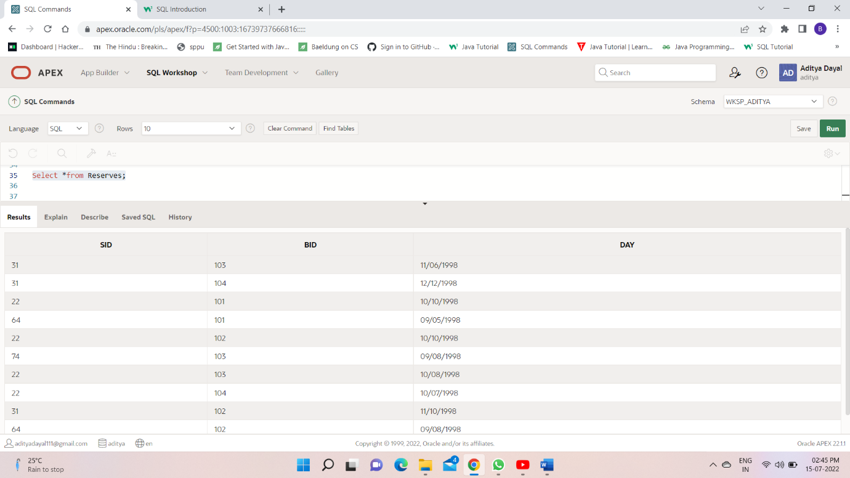

Q2.

Select sname,age from Sailor where sname LIKE 'B%b';

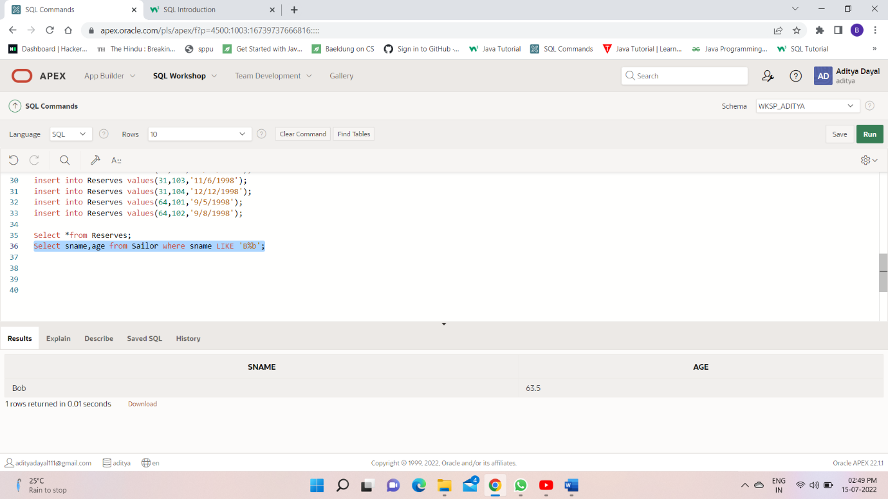

Q3,Q4,Q5,Q6,Q7,Q8,Q9,Q10.

